International Cybersecurity and Digital Forensics Academy (ICDFA)
SBT-DF203: Basic Networking Skills for Digital Forensics
LAB 8: DNS Spoofing Forensics
Three-Week Delivery Block 3/3 | 19-25 September 2026
Prepared by: Aminu Idris, AMCPN | Founder, ICDFA
Important Pre-Lab Instruction
Read the matching lecture slide deck before executing the practical. Work only inside the ICDFA-approved lab or your own isolated virtual environment. Record every command, observation and screenshot as contemporaneous evidence.
Course Code | SBT-DF203
Course Title | Basic Networking Skills for Digital Forensics
Lab Number | Lab 8
Lab Title | DNS Spoofing Forensics
Delivery Block | 3/3 of 3
Scheduled Dates | 19-25 September 2026
Estimated Duration | 4-5 hours practical work plus report writing
Mode | Individual practical lab in an authorized virtual environment
Required Evidence | Controlled DNS-spoof PCAPNG plus baseline DNS/ARP evidence

1. Source Materials and Slide Alignment
- DNS Spoofing Forensics: fake training page, ARP poisoning as a man-in-the-middle prerequisite, DNS request interception, modified response, iptables/NFQUEUE and packet analysis.
- The uploaded slide uses arp.py and dns_spoof.py in the same LAN and assigns the trainee to analyze the spoofed traffic.
- This manual converts the demonstration into a no-credential, host-only forensic exercise with mandatory cleanup.
Reading Requirement Before Lab Execution
The lab deliberately follows the sequence, terminology and core exercises presented in the uploaded SBT-DF203 slides. Commands have been corrected where needed for Linux syntax and forensic repeatability.

2. Lab Scenario
An internal training domain resolves to an unexpected host after an ARP anomaly. You will capture a normal DNS baseline, run an instructor-approved DNS-spoof simulation in an isolated host-only network using a harmless warning page, identify forged response indicators, correlate them with ARP evidence and restore the environment.

3. Learning Outcomes
- Explain the relationship among ARP poisoning, man-in-the-middle positioning and DNS spoofing.
- Capture baseline DNS and ARP evidence before a controlled simulation.
- Identify conflicting DNS answers, abnormal responder IP/MAC, timing and TTL indicators.
- Correlate a spoofed DNS response with the web connection that follows.
- Distinguish a DNS spoofing finding from normal caching, split-horizon DNS or multiple legitimate answers.
- Restore forwarding, iptables and ARP state after the lab.

4. Legal, Ethical and Safety Rules
- Use only systems, packet captures and networks for which you have explicit authorization.
- Keep the lab isolated from production, campus, office and public networks. Use NAT or host-only virtual networking as instructed.
- Do not collect, disclose or reuse real credentials, personal messages or confidential traffic.
- Preserve original capture files. Perform analysis on verified working copies and record SHA-256 hashes.
- Stop any traffic-generation or interception process immediately after the required evidence is captured.
- Restore firewall, ARP, forwarding and network settings before closing the lab.
- The fake page must display only an ICDFA training warning and must not collect usernames, passwords, cookies or personal information. Use a reserved training domain such as portal.icdfa.test or bank.training.invalid, never a real bank or public domain.

5. Required Tools and Environment
Item | Recommended Tool | Purpose
Virtual machines | Kali analyst plus victim VM | Run on a host-only/internal network.
Web server | Apache2 on analyst VM | Host harmless training page.
Capture tools | Wireshark/tshark | Capture DNS, ARP and HTTP.
Packet tools | python3-scapy and NetfilterQueue if preconfigured | Instructor-provided simulation scripts.
Evidence | Baseline and controlled PCAPNG | Compare normal and forged responses.
Test domain | Instructor-assigned .test/.invalid name | Avoid impersonating real organizations.

6. Lab Folder Structure and Evidence Preparation
mkdir -p ~/SBT-DF203-Lab8/{evidence,working,exported,reports,screenshots,scripts}
cd ~/SBT-DF203-Lab8
pwd
find . -maxdepth 1 -type d -print
Create the folder structure before downloading or generating evidence. Store original captures under evidence and analysis copies under working.
sudo apt update
sudo apt install -y apache2 tshark wireshark python3-scapy python3-pip build-essential python3-dev libnetfilter-queue-dev
sudo systemctl enable --now apache2
printf '<!DOCTYPE html>\n<html><body style="font-family:Arial"><h1>ICDFA DNS Spoofing Training Page</h1><p>This is an authorized simulation. Do not enter credentials.</p><p>Analyst: YOUR NAME</p></body></html>\n' | sudo tee /var/www/html/index.html
sha256sum /var/www/html/index.html | tee reports/training_page_sha256.txt
ip -br address | tee reports/interfaces.txt
ip route | tee reports/routes.txt
ip neigh show | tee reports/arp_before.txt

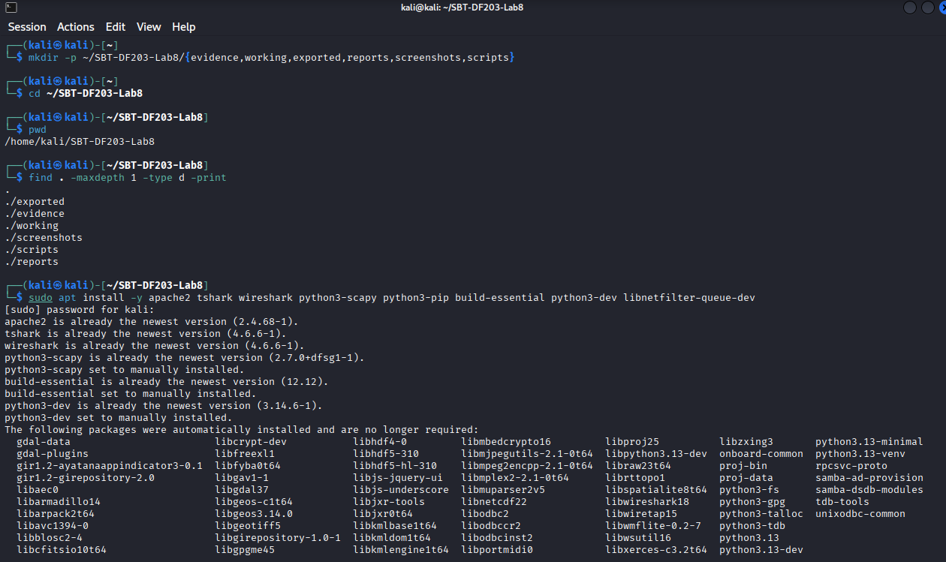

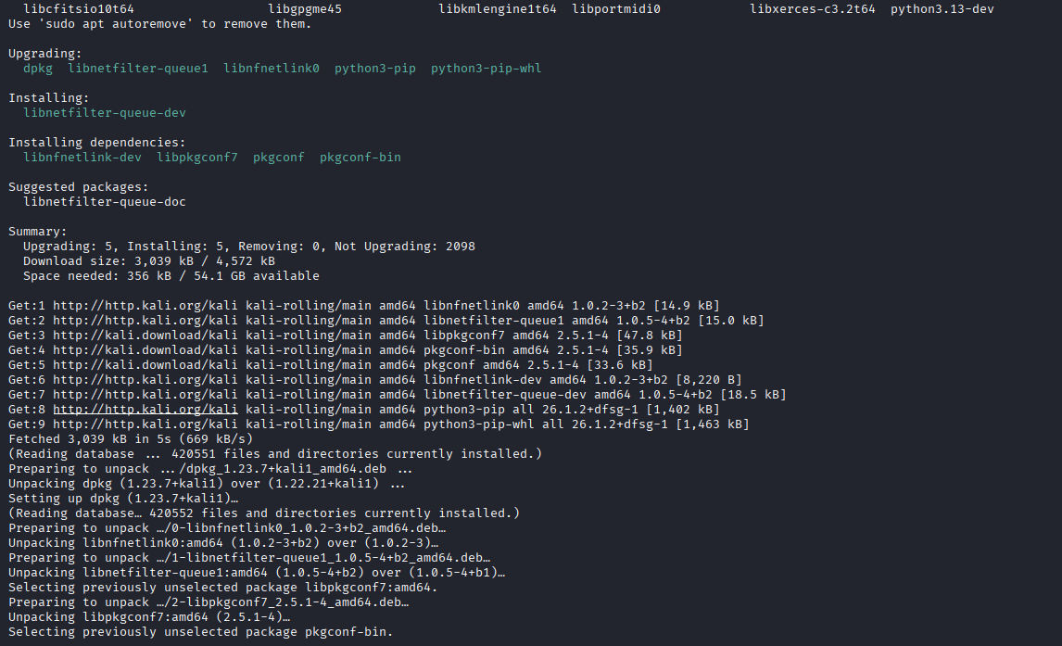

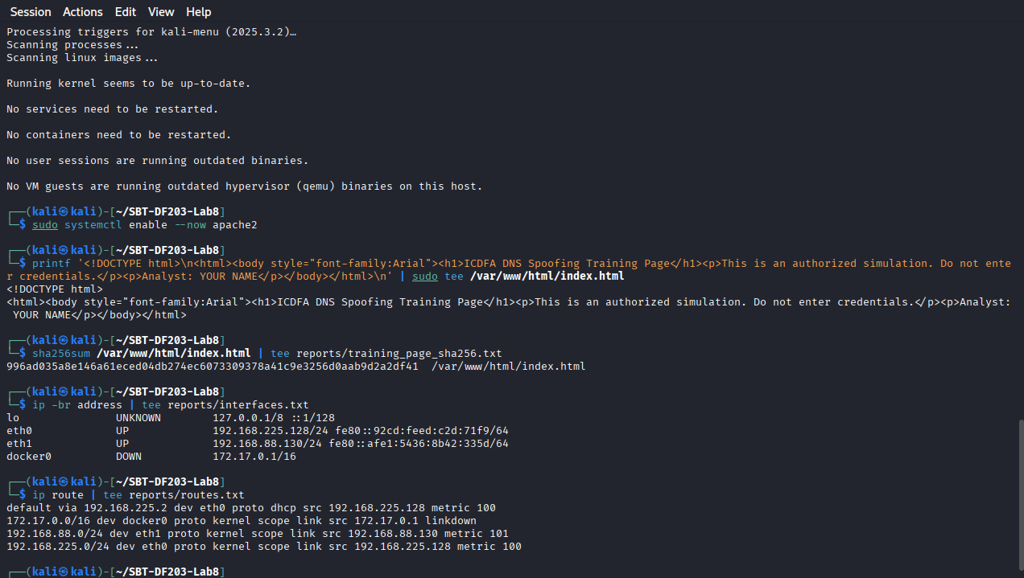

7. Mini Evidence and Chain-of-Custody Worksheet
Field | Student Entry
Case/lab identifier | SBT-DF203-Lab8-Samuel_Chinedu_Onu
Trainee name | Samuel Chinedu Onu
Date and time started | 23rd Sept 2026, 3pm
Evidence file name(s) | /var/www/html/index.html  reports/training_page_sha256.txt  reports/interfaces.txt  reports/routes.txt  reports/arp_before.txt
Source or generation method | Generated on Kali linux VM during lab setup
Original SHA-256 | 996ad035a8e146a61eced04db274ec6073309378a41c9e3256d0aab9d2a2df41
Working-copy SHA-256 | 996ad035a8e146a61eced04db274ec6073309378a41c9e3256d0aab9d2a2df41
Analysis workstation/VM | Kali linux VM
Notes on any changes | No PCAP captures generated yet

